Lab 31 - Mac Flood Attack

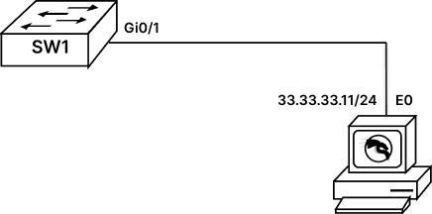

Configure MAC Flood Attack
As we have studied that Switch relies on MAC table to take forwarding decision. MAC table can be flooded with fictitious MAC entries resulting in MAC/CAM flooding Attack. This attack that is known to be very prominent on Switches, where attacker uses a tool, generally KALI to flood MAC table of SWITCH.
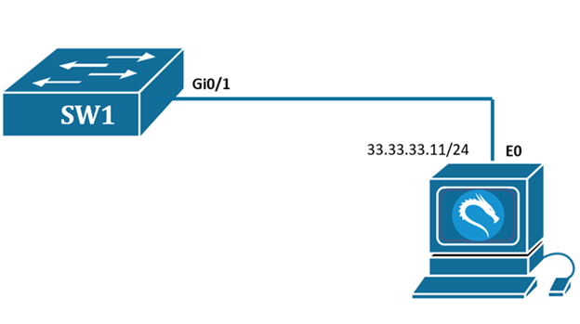
Task 1: Perform MAC Flood Attack on Cisco Switch
Step 1: To start with this lab, we will go to switch and verify MAC table.
*Note: If you do not see mac addresses, you can generate some ping traffic from Kali Machine. This will populate MAC address in Switches MAC table.
SW1# sh mac address-table
Vlan Mac Address Type Ports
---- ----------- -------- -----
1 5254.0040.ca4b DYNAMIC Gi0/1
Total Mac Addresses for this criterion: 1
Step 2: To flood mac address, we will take access of kali machine
username : root
password : rst@12345
From kali machine open terminal and type “macof -n 1000”, this command will generate 1000 fictitious MAC Addresses and will flood the MAC Table of Switch.
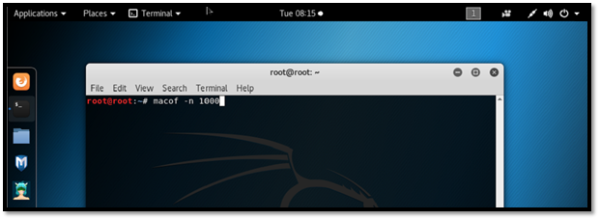
Step 3: Go to switch and verify the MAC Table
SW1# sh mac address-table
Vlan Mac Address Type Ports
---- ----------- -------- -----
1 5254.0040.ca4b DYNAMIC Gi0/1
1 0894.00d3.0da9 DYNAMIC Gi0/1
1 08f4.8004.37f6 DYNAMIC Gi0/1
1 0a3a.d343.0c42 DYNAMIC Gi0/1
1 0a58.924e.6838 DYNAMIC Gi0/1
1 0c76.3e32.0f48 DYNAMIC Gi0/1
1 0ca8.a828.85fc DYNAMIC Gi0/1
1 0ccc.a451.2710 DYNAMIC Gi0/1
1 0cd3.503d.7f08 DYNAMIC Gi0/1
--More--
Task 2: Mitigate MAC Flood Attack
Step 1: We will start by clearing flooded mac address using following command
SW1#clear mac address-table dynamic
Step 2: To mitigate MAC Flood Attack, we will enable port security feature on switch. The following command will enable port security feature, it will also set the maximum number of MAC that can be learned on the port, and it will also set the violation to “SHUTDOWN”.
SW1#conf t
SW1(config)#int gi0/1
SW1(config-if)#switchport mode access
SW1(config-if)#switchport port-security
SW1(config-if)#switchport port-security maximum 1
SW1(config-if)#switchport port-security violation shutdown
SW1(config-if)#exit
Step 3: Now we will again run the “macof -n 1000” command on Kali Linux to generate fictious mac addresses.
Step 4: Now we check the system log messages on switches console for any violation.
SW1#
*May 11 12:35:44.233: %PM-4-ERR_DISABLE: psecure-violation error detected on Gi0/1, putting Gi0/1 in err-disable state
*May 11 12:35:44.240: %PORT_SECURITY-2-PSECURE_VIOLATION: Security violation occurred, caused by MAC address fe54.00b7.7249 on port GigabitEthernet0/1.
*May 11 12:35:45.235: %LINEPROTO-5-UPDOWN: Line protocol on Interface GigabitEthernet0/1, changed state to down
*May 11 12:35:46.241: %LINK-3-UPDOWN: Interface GigabitEthernet0/1, changed state to down
SW1#
As we can see the switch has successfully detected violation on its port and has put the interface to down state.

